Found Cat
INSERT a recent good head/body shot of the animal
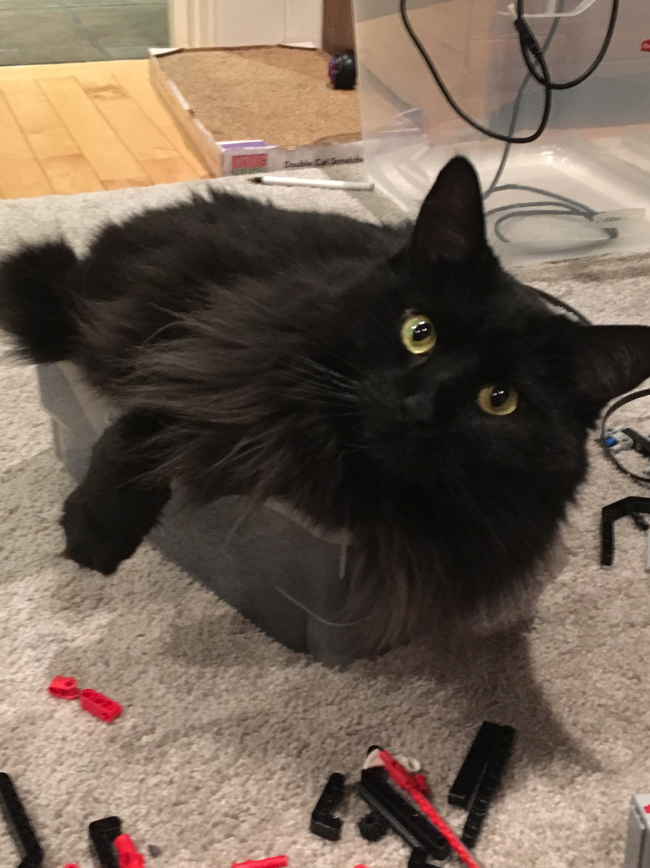
"Bella": long-hair black cat
Identifying marks: all black, long hair, fluffy tail, greenish-gold eyes. Big cat.
Found: Corner of Rowanwood and Keenan, Our City, April 7 at 8:00 p.m.
Contact (613) 555-1212
Email: BellasFinder@email.ca
Please help us get her home! Please take a pic and share.

